ADC PCB Hardware Description
Clayton Gumbrell
13 January 2009
Hardware Version 1.0

Description
The ADC module is based on the MAX1202 ADC device. This is an 8 channel 12 bit converter. It uses an SPI interface. Two MAX1202 devices are used, providing a 16 channel ADC module.
The circuit includes resistors to allow for a voltage divider on any of the channels.
The circuit includes pull up resistors (to VCC or Vref) on some of the channels. This is used to allow for thermisters to be directly connect to the converter so that resistance values can be easily measured.
The circuit allows for the devices to share a common reference voltage provided by one of the MAX1202 devices.
The full circuit diagram is shown in the document “ADC_Module_V10 schematic.pdf”
The PCB layout is shown in the document “ADC_Module_V10 overlay.pdf”

ADC Channel Allocations
There are three ADC PCBs in KiwiSAT. To allow easier management of these three, all ADC PCBs are configured identically.
Channel | Mode | Tx Tray | Rx Tray | Attic
1 | 1:1 | Linear Tx power out | Linear Rx AGC out | Magnetometer X  1.5 – 3.5V
2 | 1:1 | FM Tx power out | FM RX1 RSSI | Magnetometer Y  1.5 – 3.5V
3 | 1:1 | Beacon Tx power out | FM RX2 RSSI | Magnetometer Z  1.5 – 3.5V
4 | 1:1 | Linear Tx Current Monitor | Linear Rx Current Monitor | Magnetometer Vref  2.5V
5 | 1:1 |  |  | Horizon Sensor Visible Sensor Vref  1.25V
6 | 1:1 | Sun Sensor X out  0 – 2.5V |  | Sun Sensor X out  0 – 2.5V
7 | 1:1 | Sun Sensor Y out  0 – 2.5V |  | Sun Sensor Y out  0 – 2.5V
8 | 1:1 | Sun Sensor Valid  1.25 / 2.5V |  | Sun Sensor Valid  1.25 / 2.5V
9 | temp sensor | Linear Tx PA temp  10K thermistor | FM Rx1 temp  10K thermistor | +Z Panel Temp  10K thermistor
10 | temp sensor | -Z Panel Temp  10K thermistor | +X Panel Temp  10K thermistor | -X Panel Temp  10K thermistor
11 | 1:1 |  |  | Horizon Sensor  Visible sensor 1  0 – 4V
12 | 1:1 |  |  | Horizon Sensor  Visible sensor 2  0 – 4V
13 | 1:1 |  |  | Horizon Sensor  IR sensor 1  0 – 4V
14 | 1:1 |  |  | Horizon Sensor  IR sensor 2  0 – 4V
15 | temp sensor | FM Tx PA temp  10K thermistor | FM Rx2 temp  10K thermistor | +Y Panel Temp  10K thermistor
16 | temp sensor | Beacon temp  10K thermistor | Linear Rx temp  10K thermistor | -Y Panel Temp  10K thermistor

PCB Layout
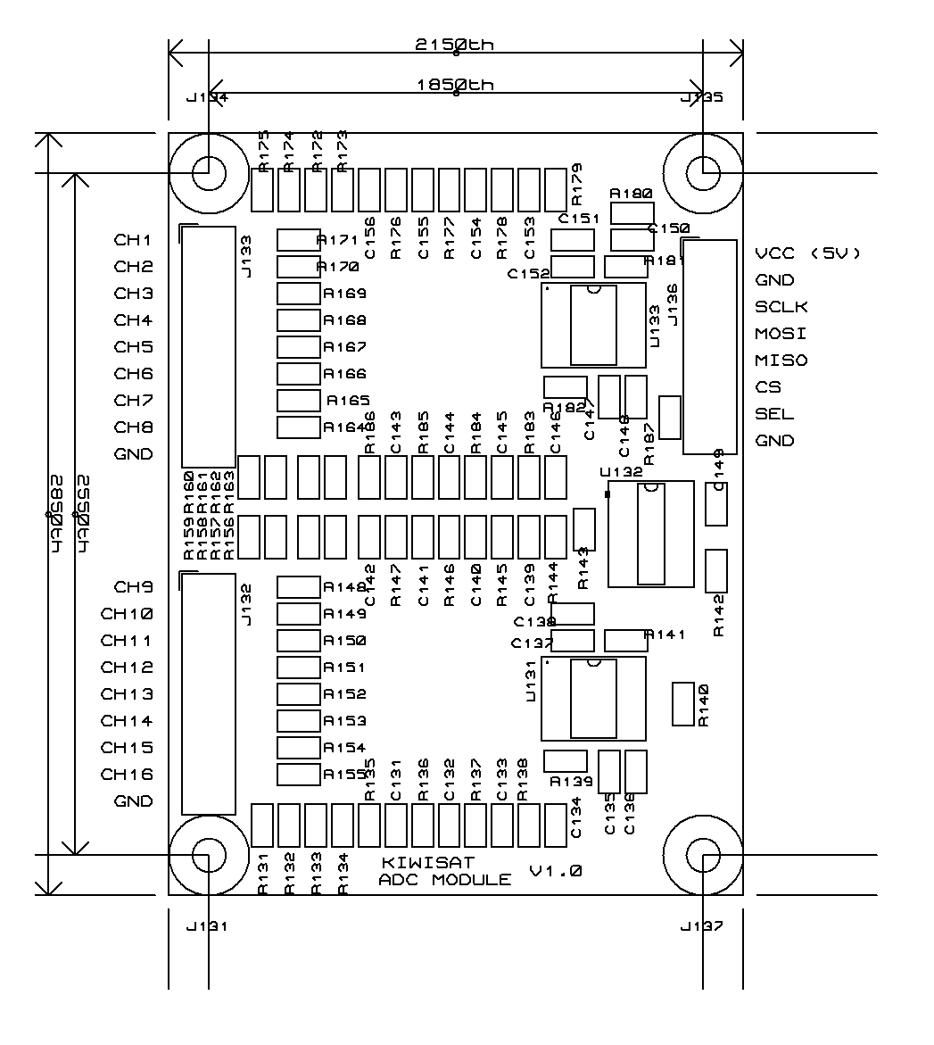
The PCB is fully SMD, so can be mounted directly onto the base with only a sheet of insulation material underneath. No stand-offs are necessary.
The connections pads are designed for wires to be directly solder on top.
The mounting holes are connected to GND.

PCB Connections
J136 connects to the IHU SPI signals
J133 and J132 are the channel inputs
Connections | Signal | Description
J136 – 1 | 5V | To 5V supply
J136 – 2 | GND | Ground (0V)
J136 – 3 | SCLK | SPI Clock input
J136 – 4 | MOSI | SPI data input
J136 – 5 | MISO | SPI data output
J136 – 6 | CS | Chip Select, active low. Pull low to enable SPI port
J136 – 7 | SEL | Select input. Set high for channels 1-8. Set low for channels 9-16
J136 – 8 | GND | Ground (0V)
J133 – 1 | CH1 | Channel input. 1:1
J133 – 2 | CH2 | Channel input. 1:1
J133 – 3 | CH3 | Channel input. 1:1
J133 – 4 | CH4 | Channel input. 1:1
J133 – 5 | CH5 | Channel input. 1:1
J133 – 6 | CH6 | Channel input. 1:1
J133 – 7 | CH7 | Channel input. 1:1
J133 – 8 | CH8 | Channel input. 1:1
J133 – 9 | GND | Ground (0V)
J132 – 1 | CH9 | Channel input. Thermistor (10K) input.
J132 – 2 | CH10 | Channel input. Thermistor (10K) input.
J132 – 3 | CH11 | Channel input. 1:1
J132 – 4 | CH12 | Channel input. 1:1
J132 – 5 | CH13 | Channel input. 1:1
J132 – 6 | CH14 | Channel input. 1:1
J132 – 7 | CH15 | Channel input. Thermistor (10K) input.
J132 – 8 | CH16 | Channel input. Thermistor (10K) input.
J132 – 9 | GND | Ground (0V)
Note:
Only 1 GND signal needs to be connected.
Thermistor inputs – connect a 10K thermistor between input and GND.
Refer to the channel allocation section for which channel signal sources for the 3 ADCs in the system.

Software
Refer to the MAX1202 data sheet for details on the SPI registers.
An ADC conversion requires three bytes to be transferred. The following sample code was used on the test-bed to take ADC readings:
unsigned int ADC_Reading( unsigned char ucPort )
{
volatile unsigned char ucData1;
volatile unsigned char ucData2;
volatile unsigned char ucReg = 0x8F;

if ( ucPort & 0x08 )
ADC_SEL_LOW();
else
ADC_SEL_HIGH();
// ADC register sel is not a normal binary value!
if ( ucPort & 0x01 )
ucReg |= 0x40;
if ( ucPort & 0x02 )
ucReg |= 0x10;
if ( ucPort & 0x04 )
ucReg |= 0x20;
// take 3 readings to allow channel to set up
ADC_CS_ENABLE();
ucData1 = SPI_Transfer( ucReg );
ucData1 = SPI_Transfer( 0 ); // read bits 11-5
ucData2 = SPI_Transfer( 0 ); // read bits 4-0
ADC_CS_DISABLE();
ucData1 = 0;
ADC_CS_ENABLE();
ucData1 = SPI_Transfer( ucReg );
ucData1 = SPI_Transfer( 0 ); // read bits 11-5
ucData2 = SPI_Transfer( 0 ); // read bits 4-0
ADC_CS_DISABLE();
ucData1 = 0;
ADC_CS_ENABLE();
ucData1 = SPI_Transfer( ucReg );
ucData1 = SPI_Transfer( 0 ); // read bits 11-5
ucData2 = SPI_Transfer( 0 ); // read bits 4-0
ADC_CS_DISABLE();
return (ucData1<<5) | (ucData2>>3);
}

Note that in this software the channels are numbers 0 – 15 (not 1-16 as in the hardware)
The SEL signal is used to select between the lower and upper sets of ports. This signal in fact selects which MAX1202 device is to be enabled.
Note that the MAX1202 port select signals do not follow normal binary patterns.
Three SPI bytes are transferred. The first is the command (channel select etc), which the result returned in the following two bytes.
When a new channel is selected it takes some time for it to settle. For this reason three complete readings are taken, with the data being returned for the last reading only. The first reading establishes the channel, the second reading is just a time filler, and the final reading returns the result. The full set of 3 readings took about 240uSec.

